**Group 25: Challenge #2 Documentation**

**Challenge #2: Easter Egg**

1. Host live site and enter the site link in 2910 shared spreadsheet.
2. Reduce the number of links to affiliated sites to three.
3. Create an Easter Egg.

**Implementation:**

Since we are using Firebase for our backend, we hosted our live site on Firebase Hosting ( <https://grocerybuddytest.firebaseapp.com> ) and filled out our information on the shared 2910 spreadsheet.

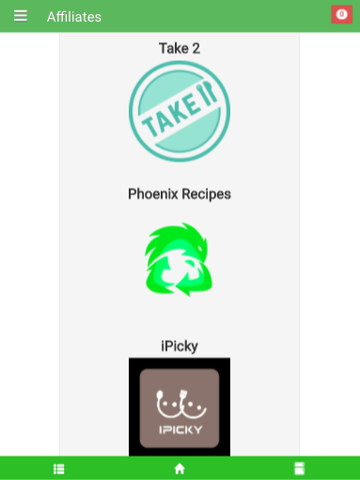We reduced the number of affiliated apps to three. Out of the four we had previously: Take2, Phoenix Recipes, iPicky and Race to Zero, we decided to let go of Race to Zero. We found that Race to Zero, which utilizes an interactive game to educate consumers about food waste is the least complementary to our web application Grocery Buddy.

Grocery Buddy is a grocery shopping list as well as an expiration date tracking app. We thought that it would make more sense for our app to be affiliated with recipe apps such as Take2 and Phoenix Recipes in order to help users use up almost expired items in the most delicious ways possible and therefore successfully reach our goal of reducing overall consumer food waste. We also thought that because iPicky is a social app which helps users plan meals for not only themselves but for social gatherings, Grocery Buddy’s functionalities help iPicky users plan what to bring to shared meals.

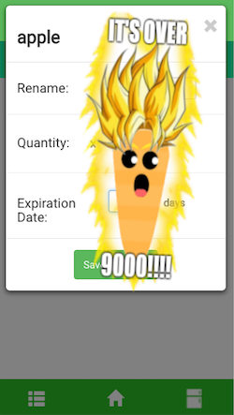Finally, for the Easter egg, we had our target audience in mind when creating the concept. Since we’re targeting millennials who are between 18-32, we wanted to implement something entertaining and fun. According to our research, millennials love memes so we decided to implement the meme super saiyan carrot for when users enter an expiration date over 9000 days. This of course could be caused by an error on their part, so we wanted to make the error into an happy accident that only shows up to those who use it enough times to discover it.